CMP 4271

Task: Territorial Acquisition.

## Game premise

The task was to make a game around the topic of territorial acquisition. The game created was a territorial acquisition game where a player had to acquire as many territories as the other players before the game ends.

## Rules and Mechanics

The rules of the game are:

* Every round starts with each player secretly picking an available land to acquire.
* Players that choose the same land will roll the dice to decide who claims it.
* Land disputes are settled with a dice roll.
* The player who rolls the highest on the dice takes the territory.
* If a player wants to claim a village as a territory, they will have to roll higher than a 4.
* Players can only move around the area they chose at the beginning of the game.

## Materials

The materials used to make the game are:

1. A board, with the territories marked out.
2. Dice.

## How to play

1. Each player chooses a marked territory to acquire in secret.
2. The players reveal their chosen territory and move to it.
3. The players that choose the same territory will have to roll the dice to determine who gets it.
4. The players have to secretly choose another territory to acquire, but only around the area they initially chose.
5. If a player chooses a territory that turns out to be a village, then the player will have to roll the dice for rights to acquire it.
6. The game continues until all territories are taken over or one of the players acquires the most before the game ends.

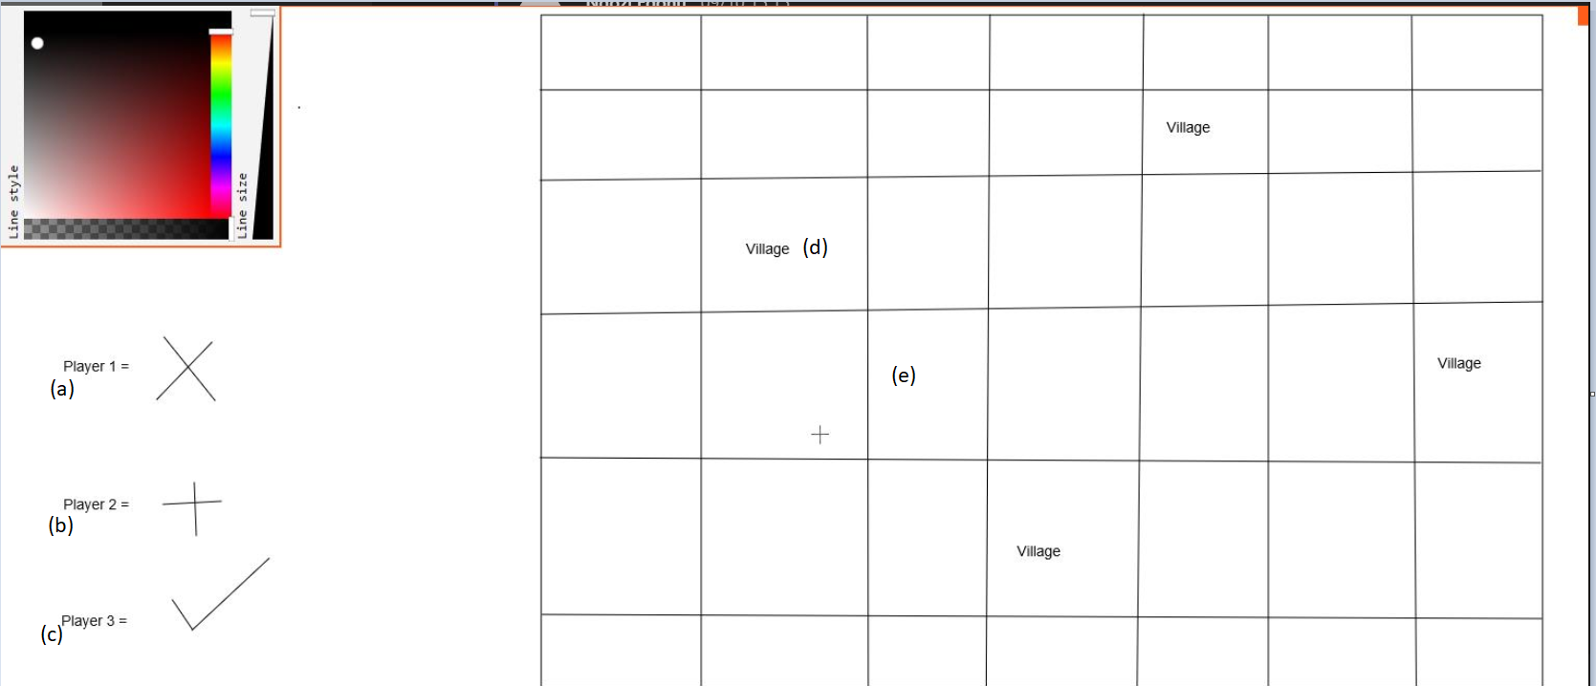

Figure 1. Board game layout. This layout shows the symbols that denote the players (a), (b) and (c). The village (d) that the players can acquire are placed randomly on the board in any acquirable land (e).

## Play Testing

External playtesting was not possible due to poor time management, but the game was internally evaluated. The number to be rolled when acquiring a village was reduced to increase the possibility of getting the number. The number of dice used was reduced from two to one, to reduce the chances of players getting the same values after a roll and to reduce the number of possibilities that further complex the game.

## Experience

The process of developing the game ran fairly smooth as the group members were cooperative and willing to work. Ideas and suggestions were taken and modified to fit the theme of the task. Although a member of the team was new to the process involving the creation of the game, the game’s development was more organised than the previous week and tasks were delegated and executed to the best of the members’ abilities. Despite the early delegation of tasks, there was no time to playtest the game because there were still aspects of the game that needed further clarification for it to make sense and parts of the game that needed to be added so that game did not become monotonous and boring. It was because of those issues that the concept of having villages as acquirable land and designated start areas came to be.

## Reflection

During the game development process, the general communication and cooperation of the team was good. Ideas were taken into consideration and the team got along well. I feel I could have managed my time better and also improve my presentation skills.

## Members of the team

The members of the design team were: Daniel Lamb, Ngozi Egonu and Mhd Yasser Alsamman.